

(INFORMATION MANAGEMENT)

EXERCISE

3
DDL Queries

Bazar, Cyrus Troy C. | Sir Sayo
4/1/2026 | 4/3/2026

- OBJECTIVES
At the end of this exercise, students must be able to:
  - Create, alter and drop tables
  - Verify that tables exist
  - Set a table to read-only and read/write status
  - Manage constraints
  - Add, modify and drop columns
  - Perform flashback operations

- BACKGROUND INFORMATION
CREATE TABLE Statement
- This statement is one of the DDL statements that are a subset of the SQL statements used to create, modify, or remove Oracle database structures.

Syntax:
CREATE TABLE [schema.]table
(column datatype [DEFAULT expr] [, …]);

Constraints
The Oracle server uses constraints to prevent invalid data entry into tables.

You can use constraints to do the following:
- Enforce rules on the data in a table whenever a row is inserted, updated, or deleted from that table. The constraint must be satisfied for the operation to succeed.
- Prevent the deletion of a table if there are dependencies from other tables.
- Provide rules for Oracle tools, such as Oracle Developer.
Data Integrity Constraints

Constraint | Description
NOT NULL | Specifies that the column cannot contain a null value
UNIQUE | Specifies a column or combination of columns whose values must be unique for all rows in the table
PRIMARY KEY | Uniquely identifies each row of the table
FOREIGN KEY | Establishes and enforces a referential integrity between the column and a column of the referenced table such that values  in one table match values in another table.
CHECK | Specifies a condition that must be true
Defining Constraints
Syntax:
CREATE TABLE [schema.]table (column datatype [DEFAULT expr] [column_constraint],
…
[table_constraint] [, …]);
- Column-level constraint syntax: Syntax:
column [CONSTRAINT constraint_name] constraint_type,
- Table-level constraint syntax: Syntax:
column, …
[CONSTRAINT constraint_name] constraint_type
(column, …),

Dropping a Table
- Moves a table to the recycle bin
- Removes the table and all its data entirely if the PURGE clause is specified
Syntax:
DROP TABLE table [PURGE];
Inserting Data into the Table
- With this syntax, only one row is inserted at a time
Syntax:
INSERT INTO table [(column [, column…])] VALUES (value [, value…]);
- Copying rows from another table Syntax:
INSERT INTO table [(column [, column…])] subquery;
ALTER TABLE Statement Syntax:
ALTER TABLE table
ADD (column datatype [DEFAULT expr] [, column datatype]…);

ALTER TABLE table
MODIFY (column datatype [DEFAULT expr] [, column datatype]…);

ALTER TABLE table
DROP (column); Adding a Constraint
Syntax:
ALTER TABLE table
ADD (CONSTRAINT constraint_name] type column_name; Dropping a Constraint
Syntax:
ALTER TABLE table
DROP PRIMARY KEY | UNIQUE (column) |
CONSTRAINT constraint [CASCADE];
- EXPERIMENTAL PROCEDURE INSTRUCTIONS:
Overview

In this exercise, you are to create new tables by using the CREATE TABLE statement, ALTER TABLE command to modify columns and add constraints, and confirm that the new table was added to the database. You will also set the status of a table as READ ONLY and then revert to READ/WRITE.

Note: You will use the DEPARTMENTS and EMPLOYEES table in the HR schema.
Use a qualifier to query data from the table in the HR schema.
Syntax: <schema>.table Example: HR.DEPARTMENTS Task
Write the equivalent SQL statements for the steps that follow.

Step 1: Create a new table DEPT table based on the following table instance chart below. Enter the syntax in the SQL Worksheet. Then, execute the statement to create the table.

Column name | ID | NAME
Data type | INT | VARCHAR
Length |  | 25
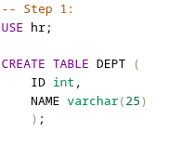

Step 2: Confirm that the table is created. Sample output is as follows:

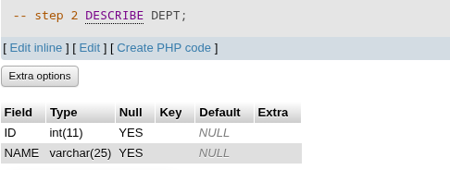

Step 3: Populate the DEPT table. Include only columns that you need.
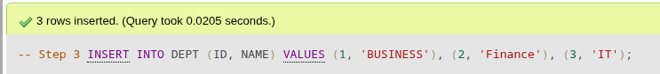
Step 4: Create the EMP2 table based on the following table instance chart. Enter the syntax in the SQL Worksheet. Then, execute the statement to create the table.

Column name | ID | LAST_NAME | FIRST_NAME | DEPT_ID
Data type | INT | VARCHAR | VARCHAR | INT
Length |  | 25 | 25
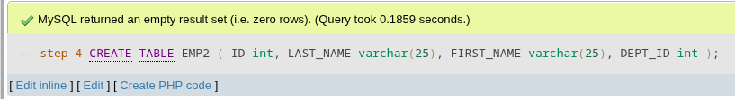
Step 5: Confirm that the table is created. Sample output is as follows.
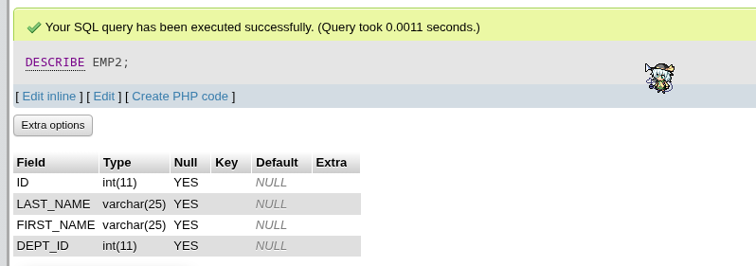

Step 6: Modify the EMP2 table to allow for longer employee last names.

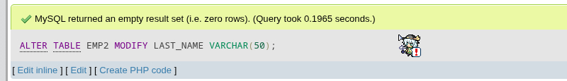

Step 7: Confirm your modification. Sample output is as follows.
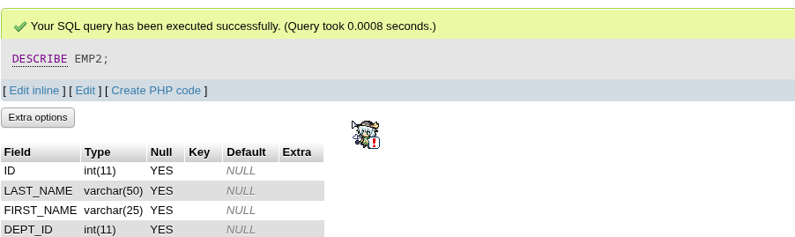
Step 8: Create the EMPLOYEES2 table based on the structure of the EMPLOYEES table. Include only the EMPLOYEE_ID, FIRST_NAME, LAST_NAME, SALARY, and DEPARTMENT_ID columns.
Step 9: Drop the EMP2 table.
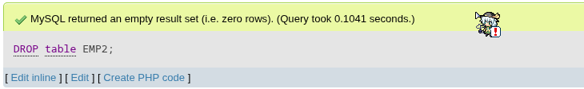
Step 10: Drop the first name column from the EMPLOYEES2 table.
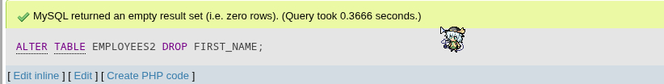
Step 11: Confirm your modification by checking the description of the table. Sample output is as follows.
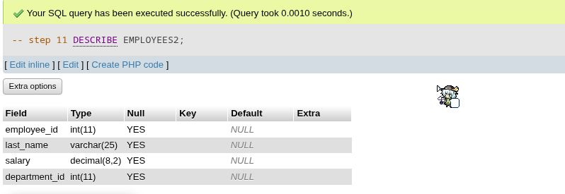

Step 12: Add a table-level PRIMARY KEY constraint to the EMP2 table on the ID column. The constraint should be named at creation. Name the constraint my_emp_id_pk
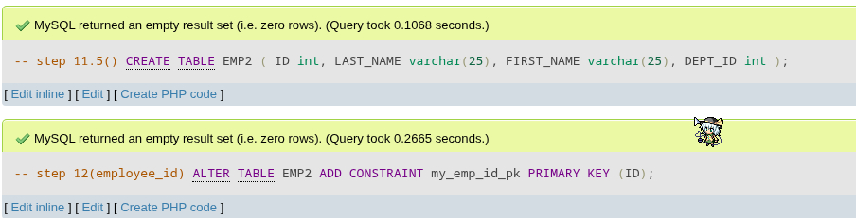

Step 13: Create a PRIMARY KEY constraint to the DEPT table using the ID column.
The constraint should be named at creation. Name the constraint my_dept_id_pk.
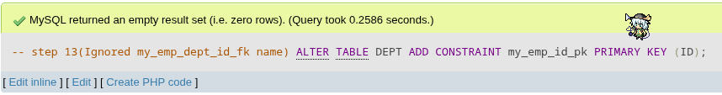
Step 14: Add a foreign key reference on the EMP2 table that ensures that the employee is not assigned to a nonexistent department. Name the constraint my_emp_dept_id_fk.
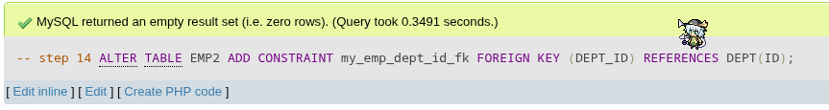
Step 15: Modify the EMP2 table. Add a COMMISSION column of the NUMBER data type, precision 2, scale 2. Add a constraint to the COMMISSION column that ensures that a commission value is greater than zero.
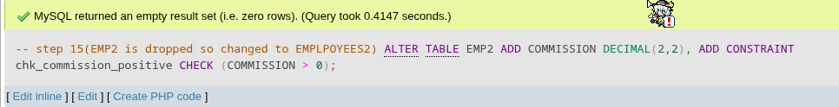
Step 16: Drop the EMP2 and DEPT tables.
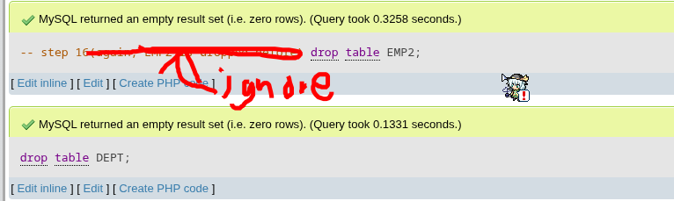

What do you observe?

The script executes smoothly and creates the tables as intended. Primary keys and foreign keys are properly set, ensuring data integrity. Columns are modified and added logically, reflecting the desired structure. Constraints enforce valid relationships between tables. Overall, the database behaves consistently and as expected.

Question and Answer

- Why is it important to use constraints (such as PRIMARY KEY and FOREIGN KEY) when defining tables in a database? How do these constraints help maintain data integrity?
- Constraints are the "rules of engagement" for a database. Without them, a database is just a collection of disorganized files. By enforcing these rules at the system level, you ensure that the data remains accurate, consistent, and reliable over time.

- What are the key differences between the CREATE TABLE, ALTER TABLE, and DROP TABLE commands? In what situations would each of these commands be used in database management?

- CREATE TABLE: Creates a table. Example: “CREATE TABLE mytable”
- used when starting and creating new tables to use later.

- ALTER TABLE: modify the structure of an existing database object, mostly tables. Example: “ALTER TABLE EMPLOYEES2 ADD COMMISSION DECIMAL(2,2),”
- Used when changing the name of column for clarity, modify column, and adding columns.

- DROP TABLE: permanently remove an existing table, its data, structure, and associated objects (like indexes and triggers) from a database. Example: “DROP TABLE User”
- Used when deleting tables, especially temporary ones.

- ASSESSMENT

Subject Code | DSA221
Description | Information Management
Term/Academic Year | 2 / SY20242025

Topic | DDL Queries
Lab Activity No | 3
Lab Activity | DDL Queries
CLO | 4

